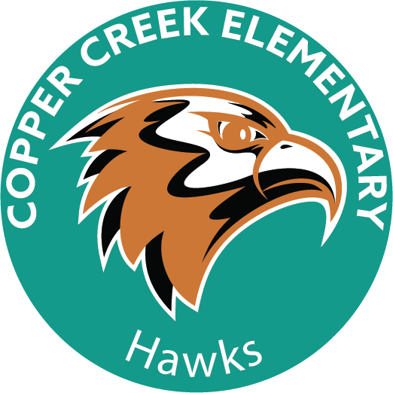

Dear Copper Creek Parents,

The Copper Creek Elementary School Parent Teacher Organization (“PTO”) wants to welcome all new and returning Copper Creek families back to school. We hope everyone enjoyed their summer break!

The PTO is hosting the annual Hawk Walk fundraiser at Copper Creek on Friday, August 25th at 8:00 a.m. This annual event is the PTO’s largest fundraiser of the year and ALL proceeds go directly to the PTO to support our children and teachers throughout the year. This fundraiser is done instead of selling candy, wrapping paper, cookie dough etc.

We know the start of school is a busy time for everyone. We host this event at the beginning of the school year because it impacts the PTO’s budget for the upcoming 2023-2024 school year. In addition, the Hawk Walk promotes school spirit and provides students, parents, and teachers the opportunity to meet and interact with one another, and our community, in a fun and healthy environment.

This is how the Hawk Walk works: Students receive donations from family, friends and neighbors to perform a fun walk around the Copper Creek campus. The walking path is full of fun surprises and ends at the legendary “Principal Messy Zone” where the students with the top 5 highest donations collected, along with one lucky raffle winner, have the opportunity to turn Mrs. Hillig and a guest into a human sundae. There are additional raffle prizes for the students as well. Students receive one raffle ticket for every fifty dollars raised.

The PTO is requesting your support with the Hawk Walk by assisting us as follows:

- Hawk Walk Envelopes will be sent home with students on Friday, August 11^{1h}. Detailed instructions will be included in the envelopes. Please make sure your child receives an envelope.

- Please help your child understand why the Hawk Walk is important and how it impacts their class, teacher and school. Please try to make time to assist our younger students collecting donations, if they need help.

- If your family is in the position to donate to the Hawk Walk, any donation amount you can give is appreciated. Please make checks payable to “Copper Creek Elementary School PTO”. Credit card payments can be made via PayPal or credit card on our website coppercreekpto.com. The Copper Creek PTO is a nonprofit 501(c)(3) organization therefore your donation may qualify for a tax deduction depending on your tax status.

- Please have your child return all Hawk Walk Envelopes to school by 8am the morning of Thursday, August 24th to be considered for the “Principal Messy Zone” prizes.

- On the day of the event Friday, August 25th please make sure your child is wearing sunscreen and has water. Please have your child wear comfortable clothes and shoes for walking.

- Volunteer and join us the day of the event! Bring silly string, bubbles or water misters to cool off the students as they walk. The Hawk Walk is a fun walking path and families are more than welcome to join in the fun!

Please view the PTO website at coppercreekpto.com for additional information and look for reminders and updates in PTO emails. We hope to see you there!

Thank you for your assistance in supporting Copper Creek!

